# [**Cube Solvo**](https://github.com/dvspandey/RubiksCube3x3)

# **Rubik’s Cube (3x3)**

# 

* Get to Know Your Rubik's Cube
* TOP layer: Step 1 - Create Daisy
* TOP layer: Step 2 - Make a WHITE Cross
* TOP layer: Step 3 - Solve WHITE Corners
* MIDDLE layer: Place Edges in MIDDLE
* BOTTOM layer: Step 1 - Make YELLOW Cross
* BOTTOM layer: Step 2 - Orient Corners
* BOTTOM layer: Step 3 - Place YELLOW Corners
* BOTTOM layer: Step 4 - Position YELLOW Edges

**Get to Know Your Rubik's Cube**

**LAYERS**

There are three horizontal layers in a 3x3 Rubik’s Cube.

Using this guide, you will solve the Rubik’s Cube layer by layer.

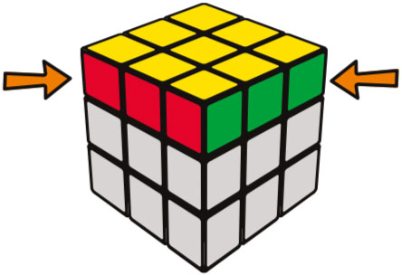

TOP LAYER

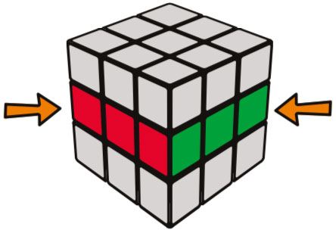

MIDDLE LAYER

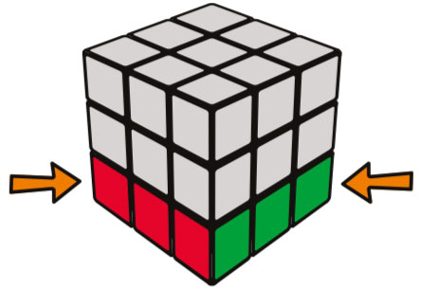

BOTTOM LAYER

**Faces**

Each flat surface is a face.

There are 6 faces on a Rubik’s Cube.

You can place your palm flat on a FACE.

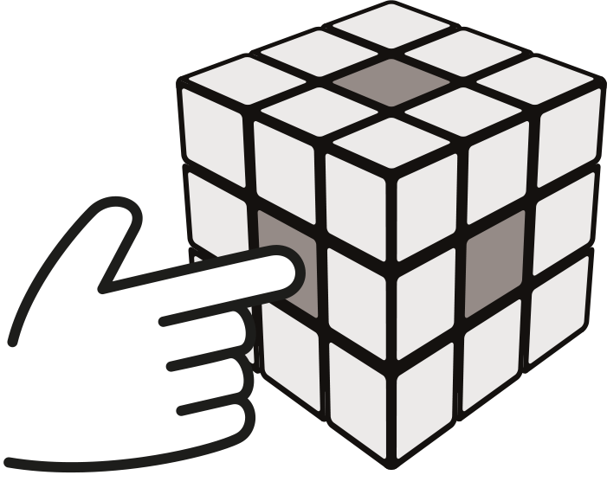

**Centers**

Center pieces have one colored tile.

There are 6 centerpieces.

Center pieces are single tiles, fixed to the internal core.

When correctly solved, each face will be the color of its centerpiece.

You use one finger to touch a CENTER piece.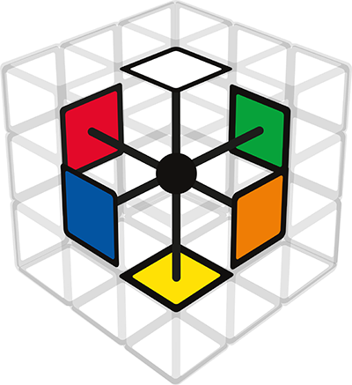

These centerpiece colors are always opposite each other:

**WHITE** opposite **YELLOW**

**BLUE** opposite **GREEN**

**ORANGE** opposite **RED**

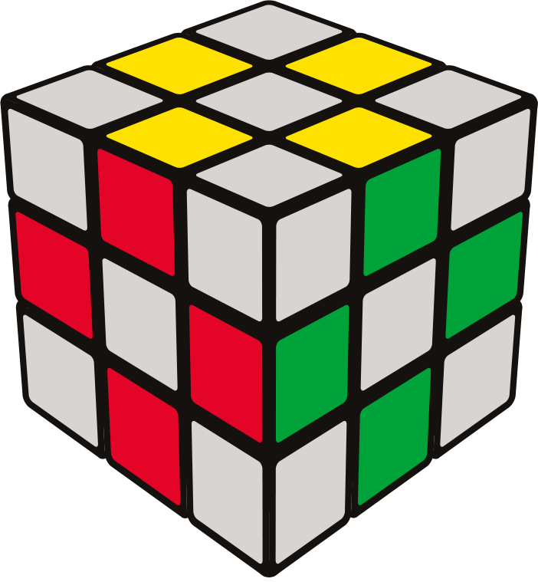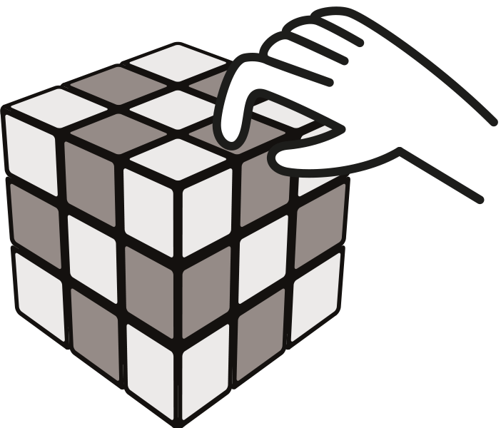

**Edges**

Edge pieces have two colored tiles.

There are 12 edge pieces.

You use two fingers to pinch an EDGE piece.

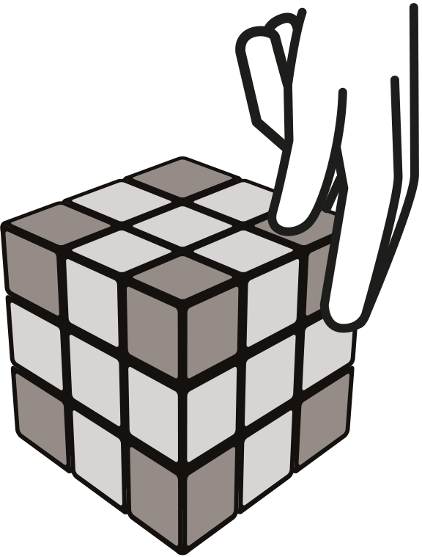

**Corners**

Corner pieces have three colored tiles.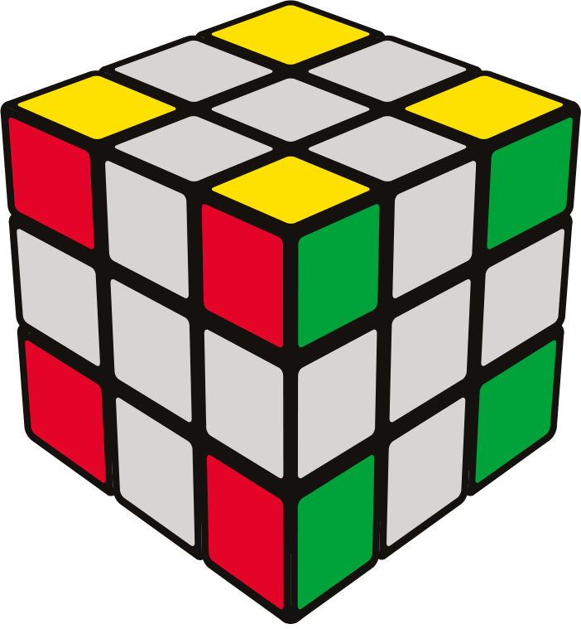

There are 8 corner pieces.

You use three fingers to touch all the sides of a corner piece.

Cube Solvo | All Rights Reserved 2021© | Pandey's Production

**GET TO KNOW YOUR RUBIK’S CUBE**

**FACE KEY ALGORITHM KEY**

Each face is represented by a letter. Moves used in this guide.

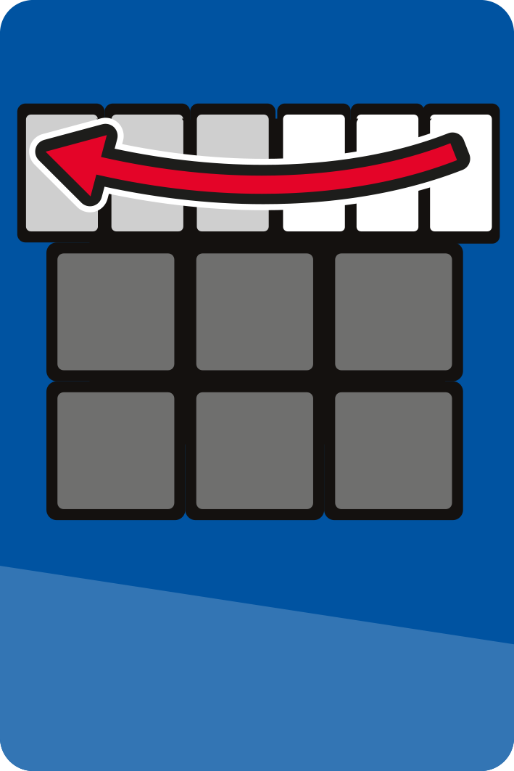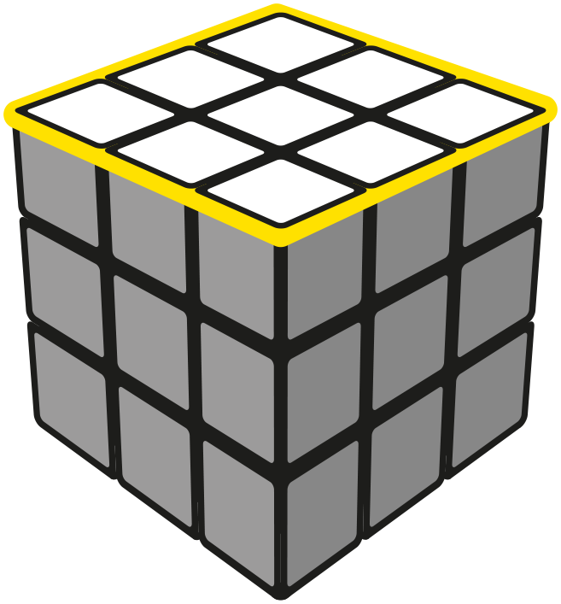

**U =**

**UP FACE**

**U U’**

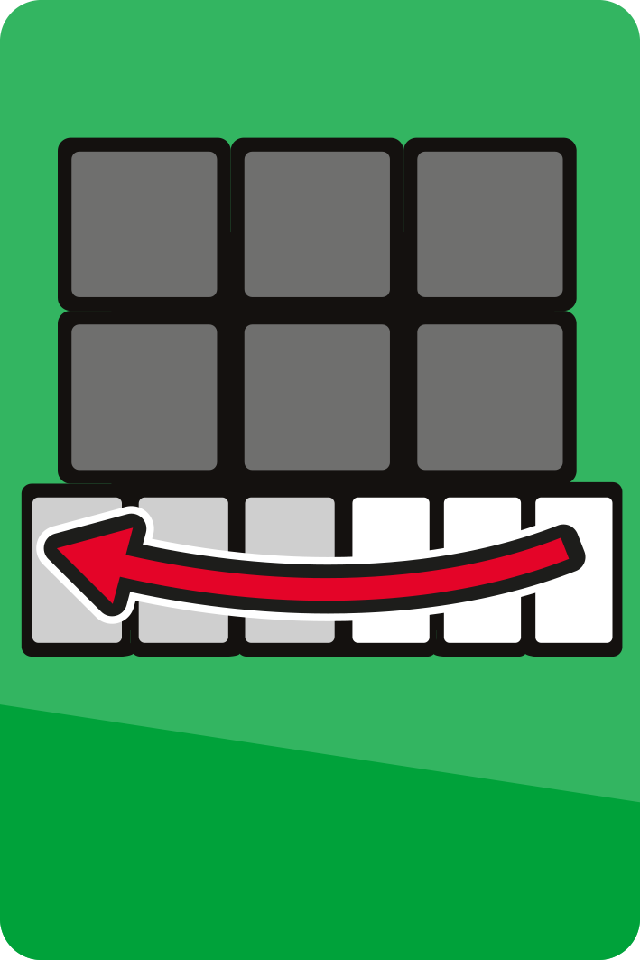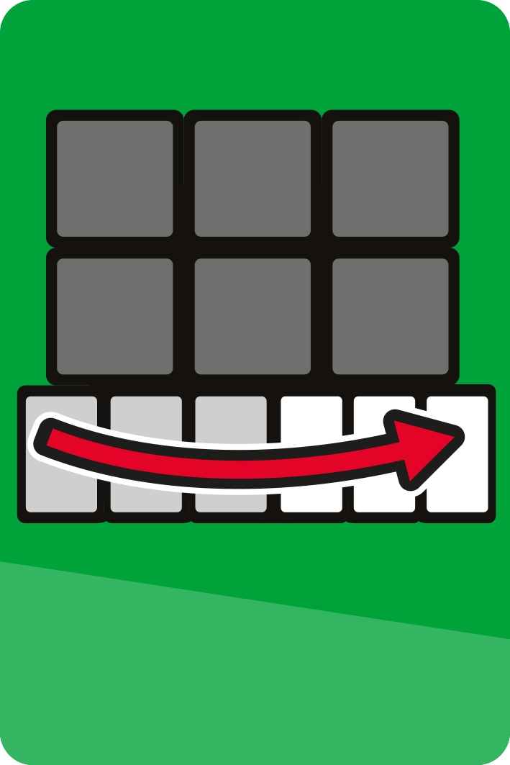

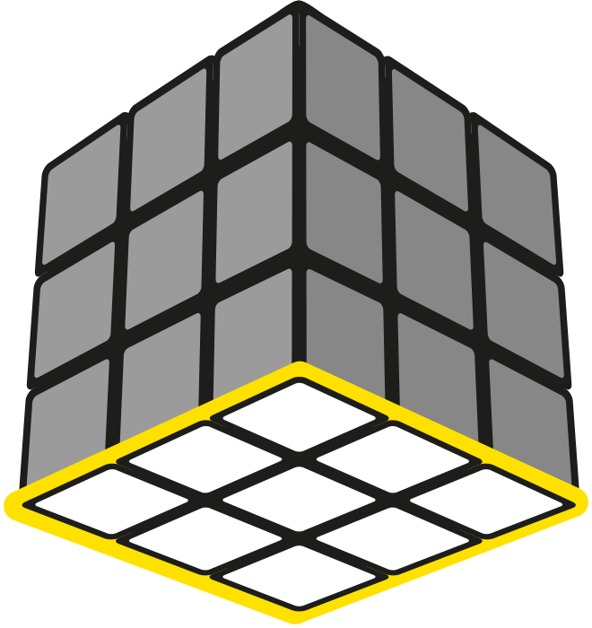

**D =**

**DOWN FACE**

**D D’**

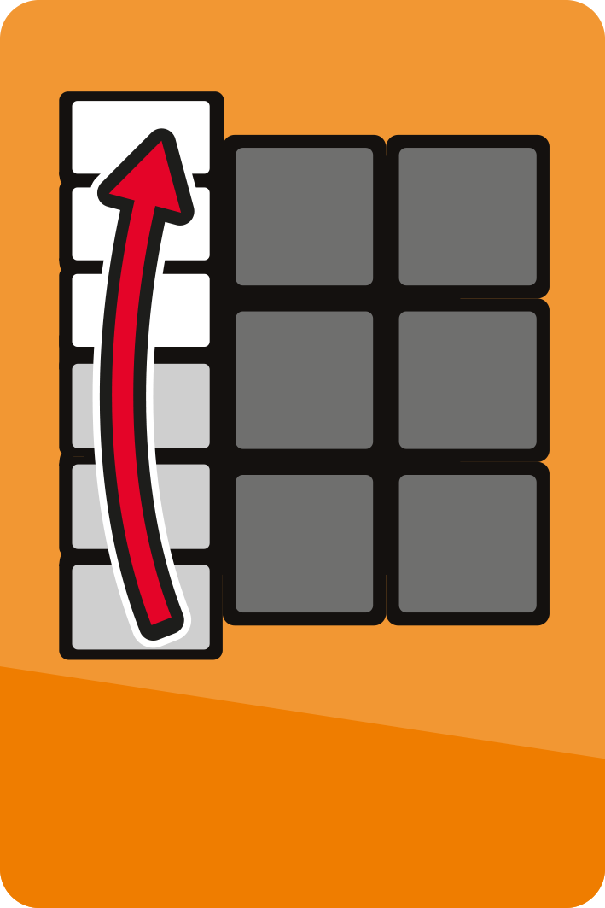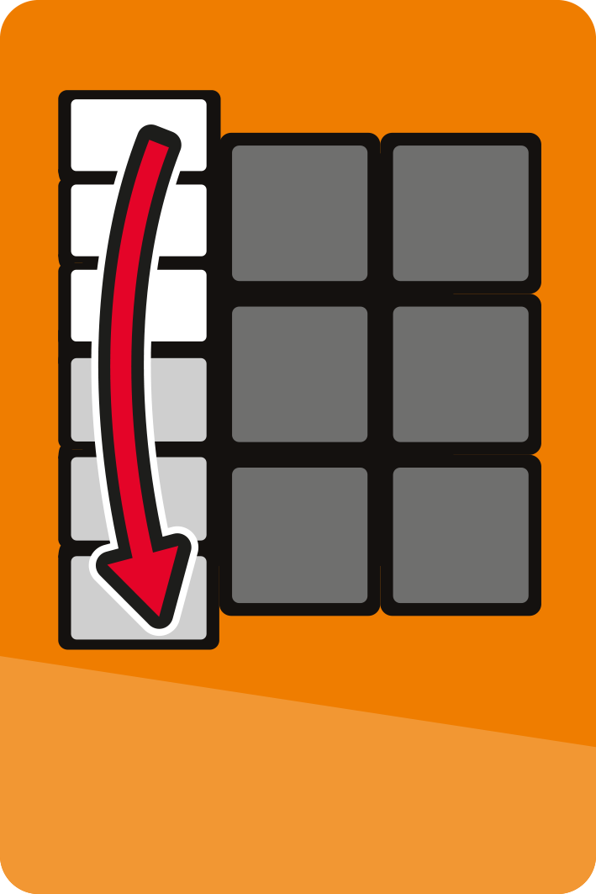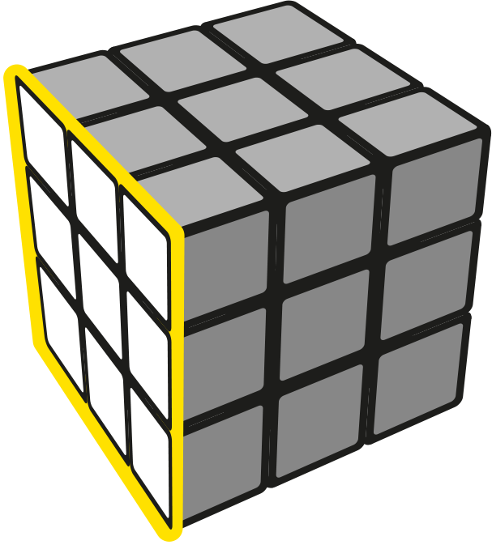

**L =**

**LEFT FACE**

**L L’**

Cube Solvo | All Rights Reserved 2021© | Pandey's Production

**F =**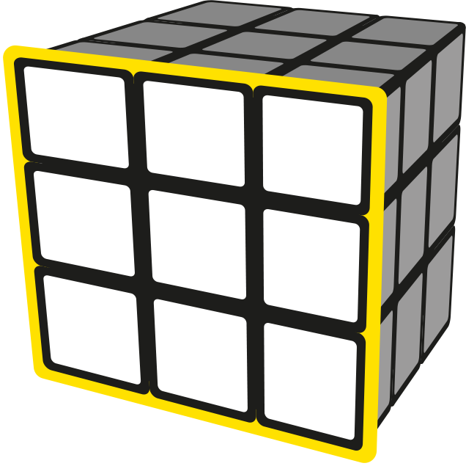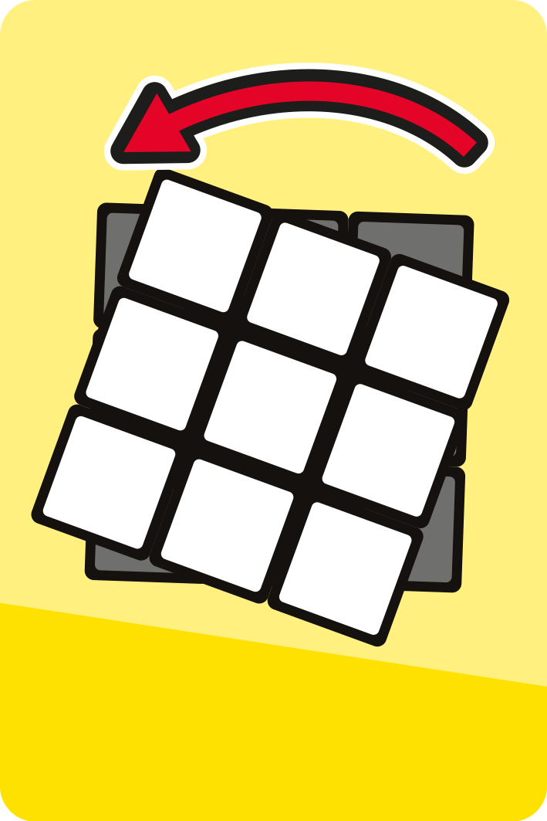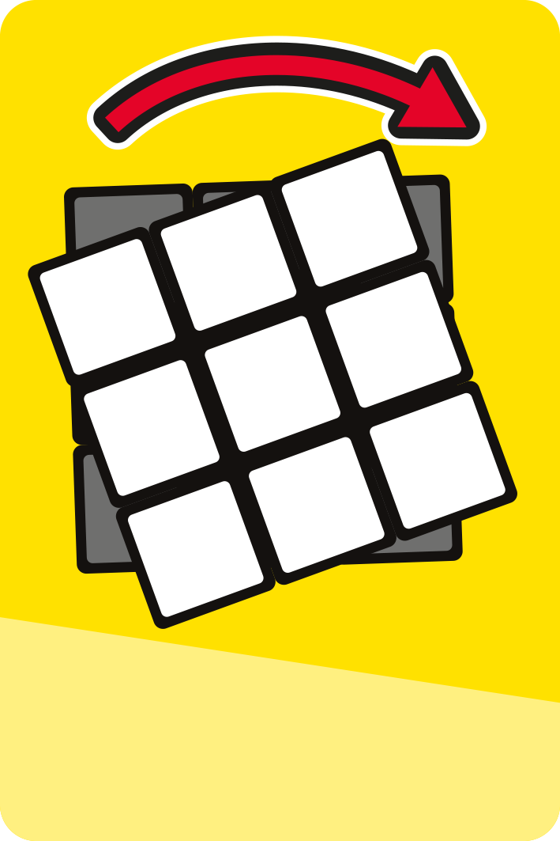

**FRONT FACE**

**F F’**

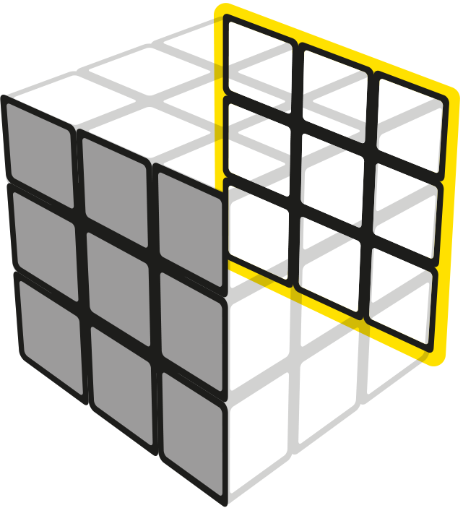

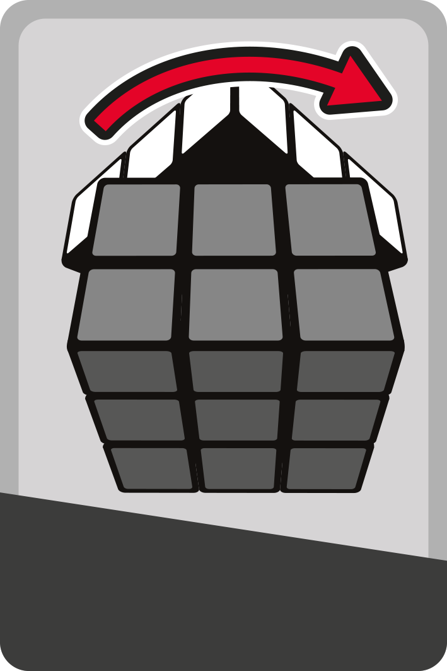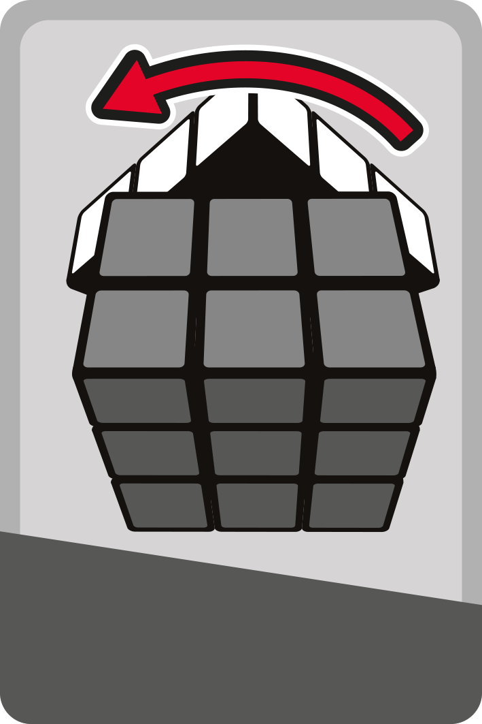

**B =**

**BACK FACE**

**B B’**

* If there is a **2** next to the algorithm letter, turn the face twice.



**=**

D D’

Cube Solvo | All Rights Reserved 2021© | Pandey's Production

* A turn is clockwise when looking at that face directly. A letter with an apostrophe **(‘)** after it means to make an inverse or counterclockwise turn of the face.



F

**IMP Points**

* An ALGORITHM is a sequence of moves that you need to do in a specific order.
* When following the algorithms in this guide, it is important to maintain the FRONT face of your Rubik’s Cube so it stays the FRONT through all of the turns.

[Cube Solvo | All Rights Reserved 2021© | Pandey's Production](https://github.com/dvspandey/RubiksCube3x3)